Contact:
Wahid Moorad
press@sigmasoft.de
+49-241-89495-1006
Kackertstr. 16-18
D-52072 Aachen

Press Release

SIGMASOFT® 6.2 is now available
Aachen, June 2026 – Aachen-based company, SIGMA Engineering, is introducing
version 6.2 of its injection molding simulation software, SIGMASOFT® Virtual Molding, which includes numerous new features and improvements. SIGMASOFT now delivers even more accurate simulation results, and the simulation and analysis process—starting with the project setup—has become more efficient and streamlined. In addition, several interesting enhancements have been introduced.
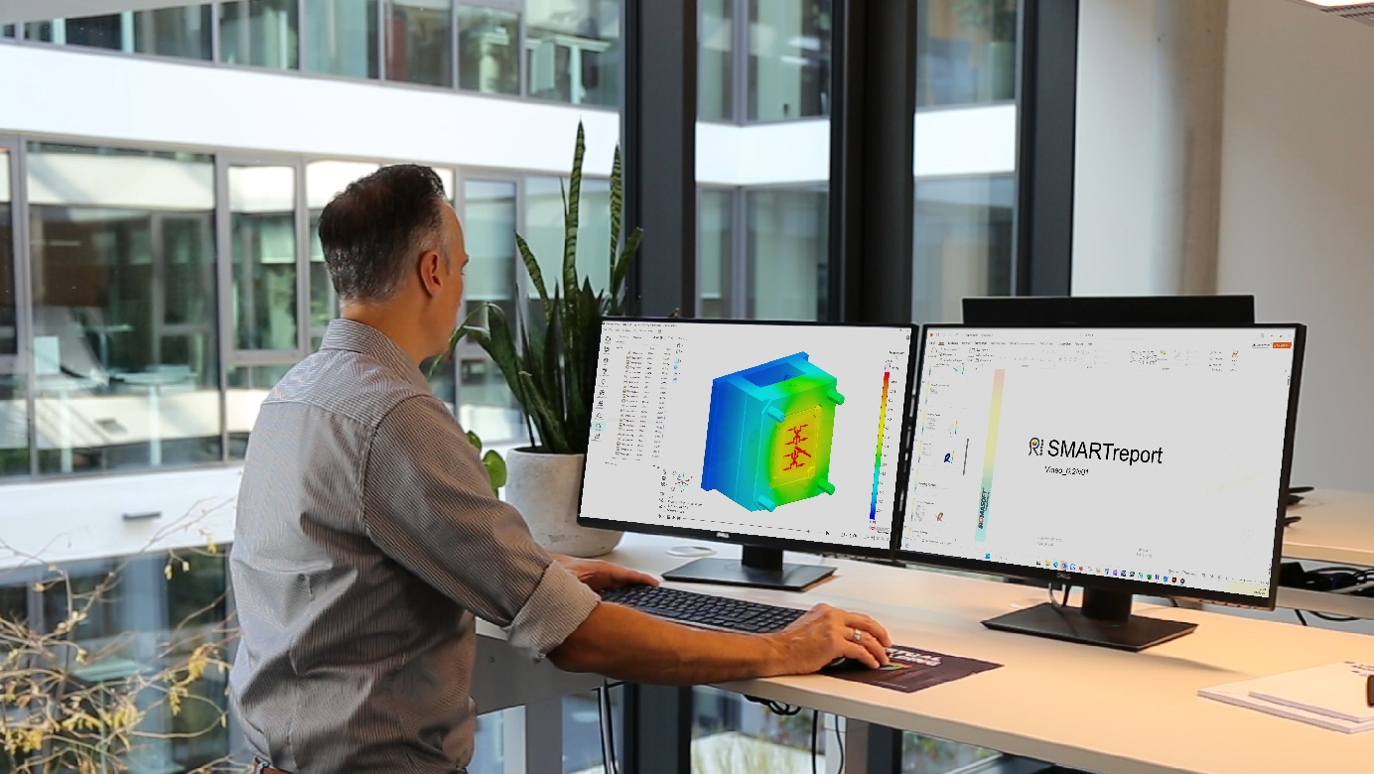Figure 1: SIGMASOFT 6.2 with numerous enhancements

SMARTreport
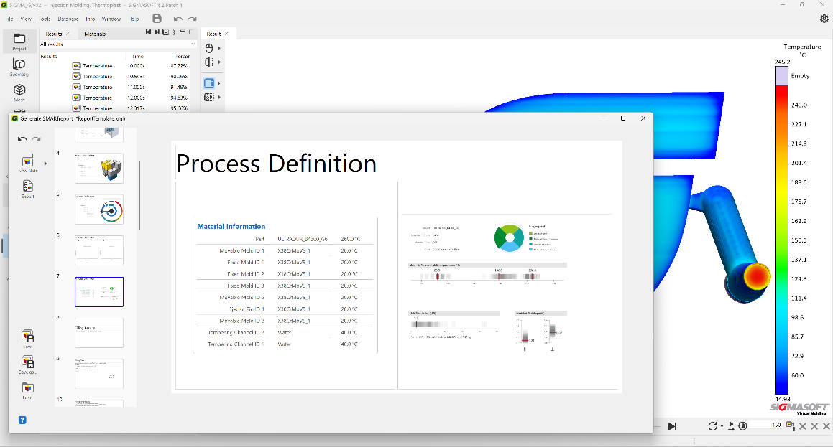
The new SMARTreport feature allows users to create a comprehensive PowerPoint presentation containing the most important simulation settings and results with just a few clicks. The report’s structure can be customized to meet the company’s specific requirements and saved in the company’s own corporate design, as well as using a company-specific PowerPoint template. This enables standardized, professional reporting, significantly reduces manual effort, and ensures a high level of consistency across all projects.
Figure 2: Quickly export all details to PowerPoint using SMARTreport
Advanced viscoelastic material model
A new three-dimensional viscoelastic material model has been introduced to significantly improve the predictive accuracy of filling simulations. By more accurately modeling time- and temperature-dependent material behavior, this model enhances flow characteristics, pressure build-up, free-jet formation, and the overall reliability of the simulation—particularly under demanding processing conditions.

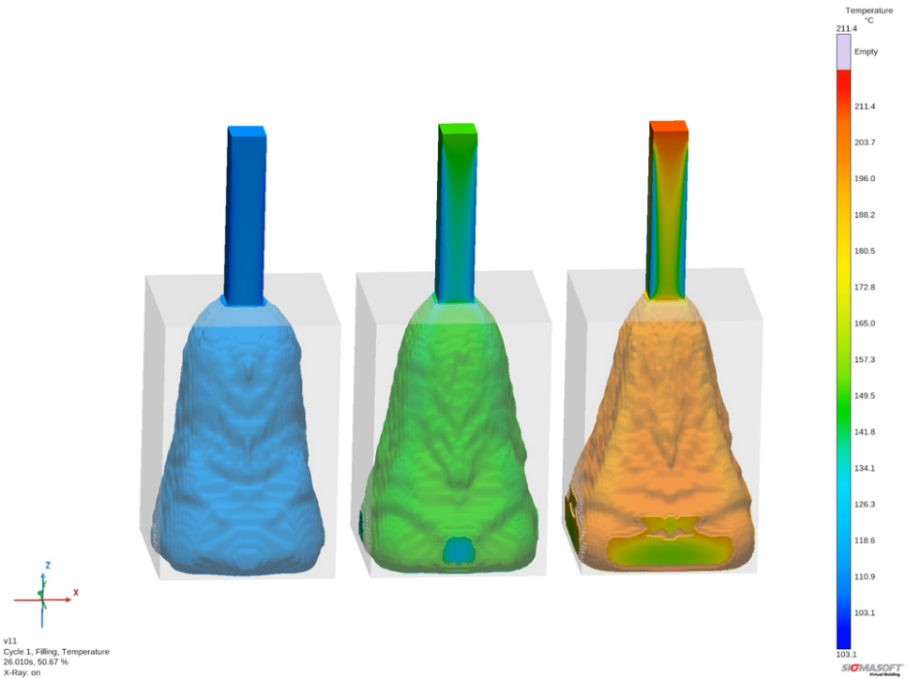

Figure 3: Obtaining accurate results (right) using the correct material properties
Material Fingerprint for plastics
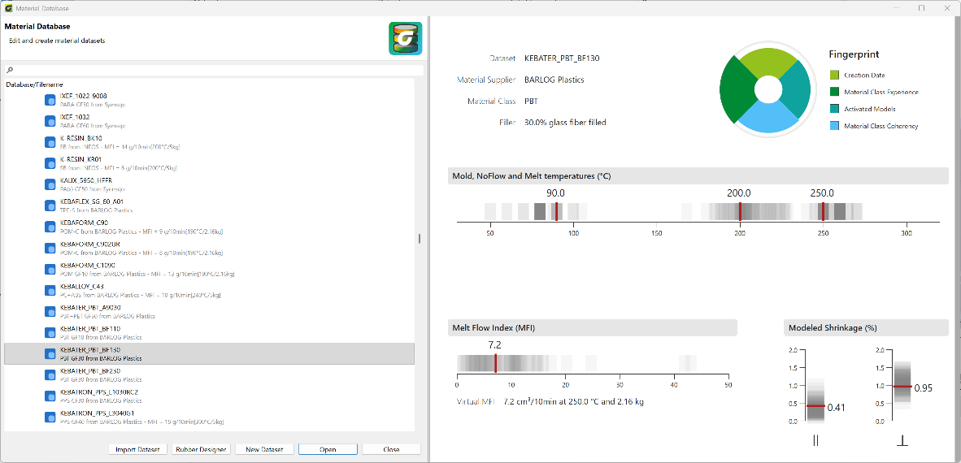
The new Fingerprint feature provides a clear and concise overview of the processing-related properties of plastic materials. It visually summarizes key process conditions and, highlights both the characteristics and the completeness of the underlying dataset. This enables users to quickly assess a material’s suitability and compare the quality of different material data in a structured and intuitive way.

Figure 4: Quickly and intuitively evaluate and compare material data
Mirror Cutbox for Visualizing Results
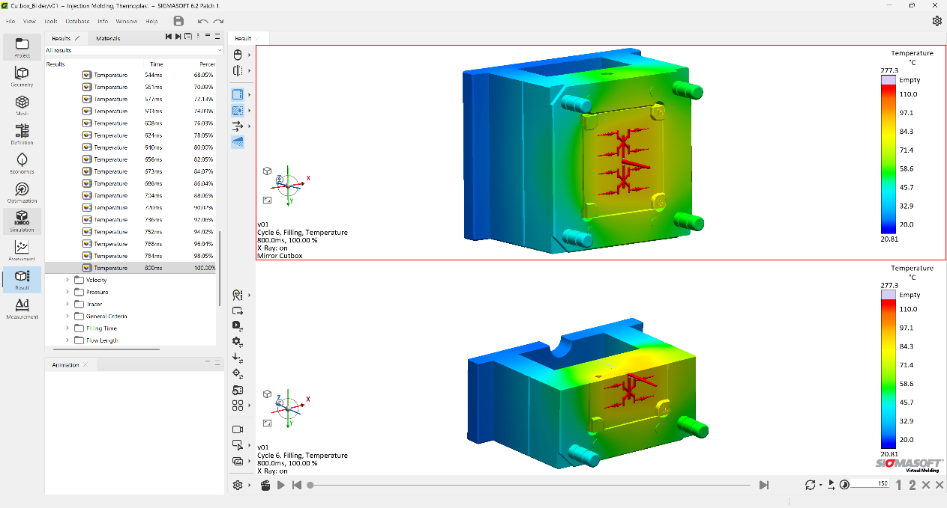
To save computation time, symmetrical tools can be split so that, for example, only one quarter is calculated. However, the resulting visual output was difficult to interpret. The Mirror Cutbox feature now allows simulation results to be mirrored along the split surfaces. This produces a complete and intuitive representation of the results, significantly improving the efficiency of the analysis.
Figure 5: Calculate half but display everything
SurroGate Model
Until now, modelling gates—which are very small relative to the part—required the use of correspondingly small finite volumes in the model. With the introduction of the SurroGate Model, these areas are now replaced by equivalent placeholders. This approach now enables significantly improved mesh quality in critical gate areas. Now, parts without critical thin-walled areas can be modelled much coarser without any significant loss in accuracy. This makes the calculation not only more robust but also considerably faster.

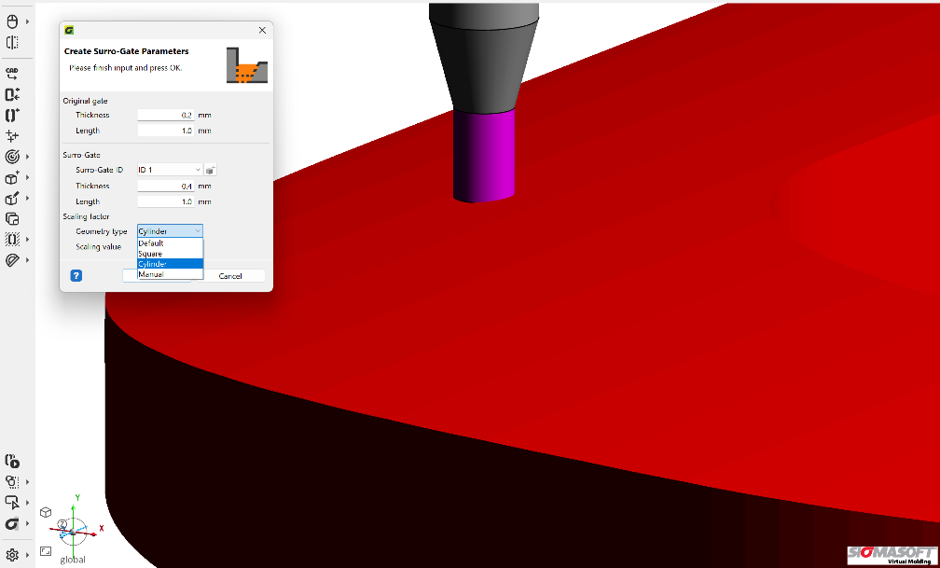
Figure 6: A placeholder instead of a densely interconnected sprue
Extended Material Database
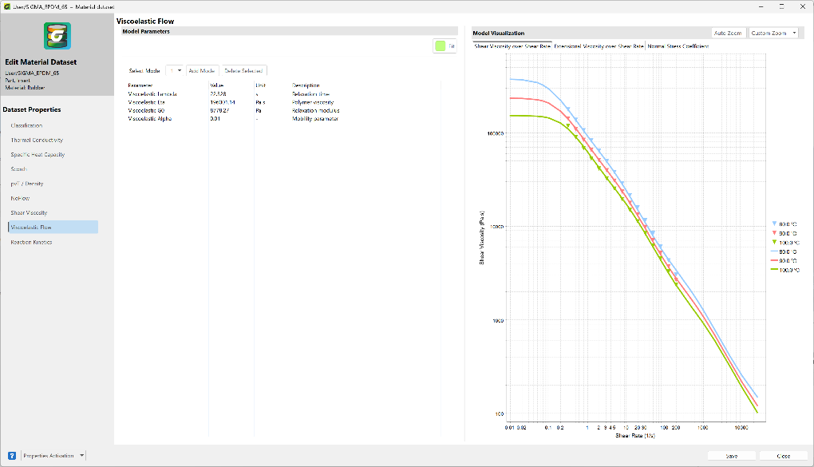
To deliver simulation results quickly and accurately, all material data must already be available in the software. SIGMASOFT has always maintained a comprehensive database. The database has been updated and improved in the latest version to ensure higher data quality, consistency, and reliability. In addition, numerous new materials have been added.

Figure 7: Effective simulation requires accessible and accurate material data

Now available
SIGMASOFT 6.2 significantly expands the capabilities of injection molding simulation for all polymers and helps customers optimize their manufacturing processes in a targeted manner—with greater efficiency, precision, and sustainability. Hundreds of specialists have already received the new version as part of their maintenance contract. The SIGMA Solution Service team is happy to demonstrate the benefits of this advanced process simulation to new prospects—including as part of a benchmark.

Since 1998, SIGMA Engineering GmbH has been driving improvements in the injection molding process with its SIGMASOFT® Virtual Molding simulation solution. This virtual injection molding software enables the optimization and development of plastic components and molds, as well as the simulation of the entire process control. This is because SIGMASOFT® Virtual Molding technology combines the 3D geometries of the part with the mold and temperature control system and integrates the parameters of the production process. This enables cost-efficient, resource-saving production and high-performance products—right from the first shot.
SIGMASOFT® Virtual Molding integrates a wide range of process-specific models and 3D simulation technologies that have been developed and validated over decades and are continuously optimized. The SIGMA solution and development team supports customers’ technical goals with application-specific solutions. The software company SIGMA offers direct sales, application engineering, training, installation, and a Solution Service provided by engineers throughout Europe.
With subsidiaries of its sister companies in the USA, Brazil, Singapore, China, India, Korea, and Turkey, SIGMA supports users worldwide in a wide range of international companies and research institutions with its Virtual Molding technology.
Further information: sigmasoft.de

This press release is available for download in PDF format at the following link: https://www.sigmasoft.de/en/about-us/press/

